## AYALA ALABANG R1P

**1.5 Load Flow Analysis**

The load flow study (analysis) has been conducted per applied standard. Following Terms are

important in the study, thus being extracted from the Philippines Distribution Code for ease of

readers.

* **ACTIVE POWER :**

The time average of the instantaneous power over one period of the electrical wave, measured in watts (W) or multiples thereof. For AC circuit or Systems , it is the product of the root-mean –square (RMS) or Effective value of the voltage and the RMS value of the in-phase component of the current. In a three phase system, it is the sum of the Active Power of the individual phases.

* **APPARENT POWER:**

The product of the root-mean –square (RMS) or Effective value of the current and root –mean –square of the voltage. For AC circuit Systems, it is the square root of the sum of the squares of the Active Power and Reactive power, measured in volt-amperes (VA) or multiples thereof.

* **REACTIVE POWER**

The component of the electrical power representing the alternating exchange of stored energy (inductive or capacitive) between sources and loads or between two systems, measured in VAR, or multiples thereof. For AC circuits or systems, it is the product of the RMS voltage and the RMS value of the quadrature component of alternating current. In a three phase system, it is the sum of the Reactive power of the individual phases

* **HARMONICS (THD)**

Harmonics shall be defined as sinusoidal voltage and currents having frequencies that are integral multiples of the fundamental frequency.

1.5.1 **Analysis based on design**

The analysis has been conducted under the assumption of the Alert Setting shown in Table

1.6. Results of the analysis are shown in the diagram (refer to Figure 1.6) with all details

summarized in tabular forms (refer to the Appendix)

As can be seen from the figure, parameter values are all acceptable. However, there is an

indication in red color for VFD1 and VFD2 inferring that this asset might have reached the critical

setting.. It is recommended that this asset shall be closely monitored. The conclusion on this asset will be validated together with the analysis on the Power Quality which is in subsection 1.8.

Summaries on the results are also shown in Table 1.7, Table 1.8, and Table 1.9.

It is concluded from this analysis that all parameter values are within the acceptable ranges.

**1.5.2 Analysis based on measured data from the PQA**

Analysis has been conducted for the overall system (refer herein as MAIN), for Feeder to motor

with VFD1, VFD2 and Softstarter3 respectively. The detailed reports were obtained from the analytical

software (refer to Appendix) with highlights presented in Figure 1.7, Figure 1.8, and Figure 1.9.

Following conclusions can be derived from the reports

* For the overall system, the maximum loading reached about Phase A :541.8A, Phase B:558.3A, and Phase C: 558.6A (Figure 1.7), which is close to 82% to the theoretical value (685A) obtained from ETAP software (Figure 1.6). This indicates that actual parameter values are within the acceptance range;
* For the VFD1, the maximum loading reached about Phase A:67A, Phase B: 73A, Phase C: 73.8 A (Figure 1.8), which is lower than the theoretical values (144A) obtained from ETAP software (Figure 1.6). This indicates that the motor may not utilized to its full capacity or at the time of reading, the demand is low which resulted to the low values.
* For the VFD2, the maximum loading reached about Phase A:110.4A, Phase B: 116.1A, Phase C: 117.5 A (Figure 1.8), which is close to 82% than the theoretical values (145A) obtained from ETAP software (Figure 1.6). This indicates that actual parameter values are within the acceptance range;
* For the softstarter, the maximum loading reached about Phase A: 425.3 A, Phase B: 434A, Phase C: 431.7A (Figure 1.9), which is higher than the theoretical values (152.3 A) obtained from ETAP software (Figure 1.6). This indicates that actual parameter values are not within the acceptance range. The actual values recorded may be coming from the inrush current on the energization of the motor.

From this analysis, it is recommended that continuous monitoring on VFD1 and softstarter3 shall be implemented to ensure that the loading is not going to exceed the limit most specially for softstarter3.

Table 1.6 Alert Settings



Table 1.6.1 Critical Report

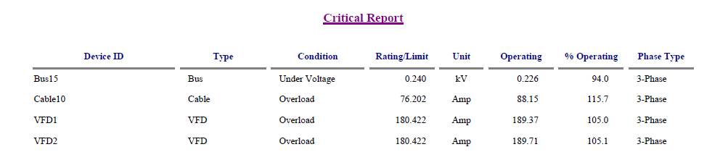

Table 1.7 Summary of total generation, loading and demand

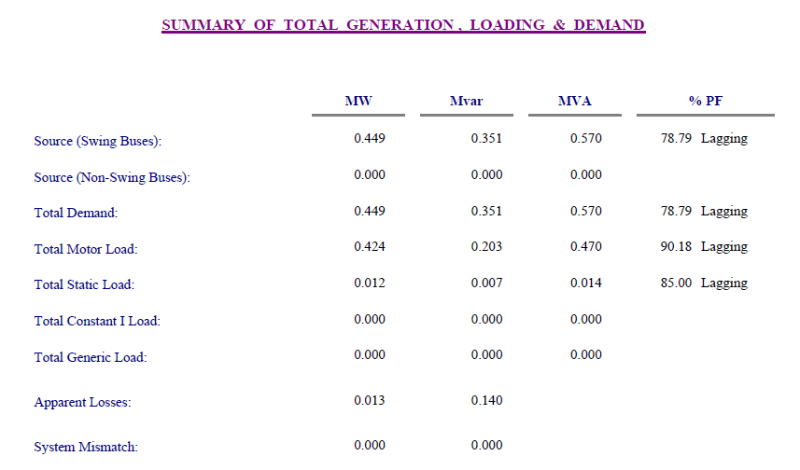

Table 1.8 Bus loading

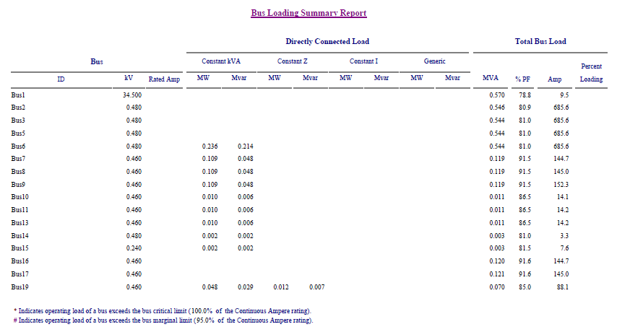

Table 1.9 Branch Loading

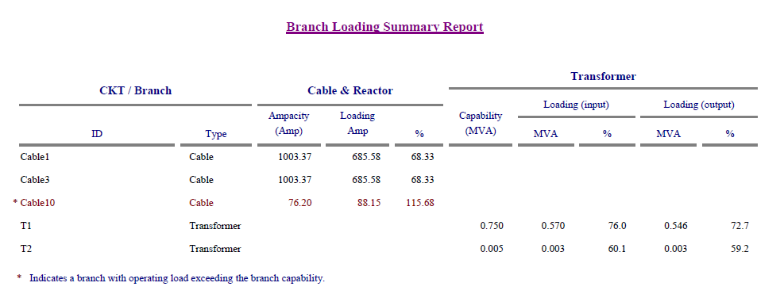

Figure 1.6 Load flow analysis

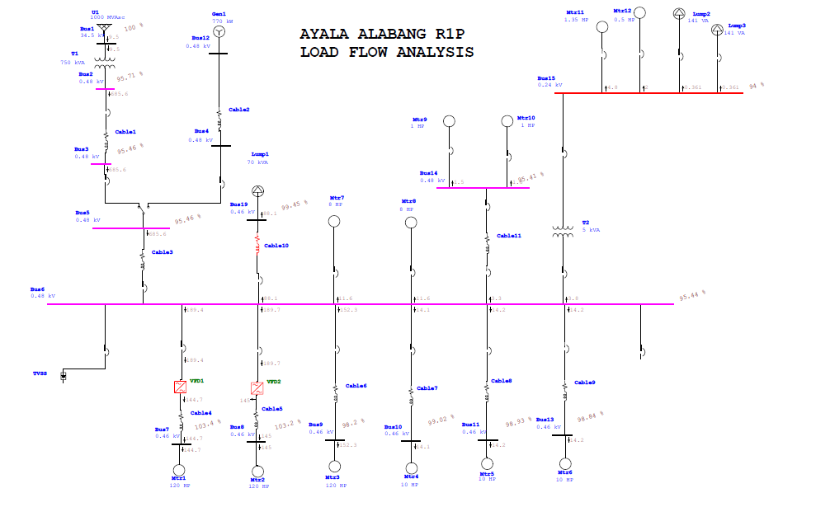

Figure 1.7 Main 1250A Loading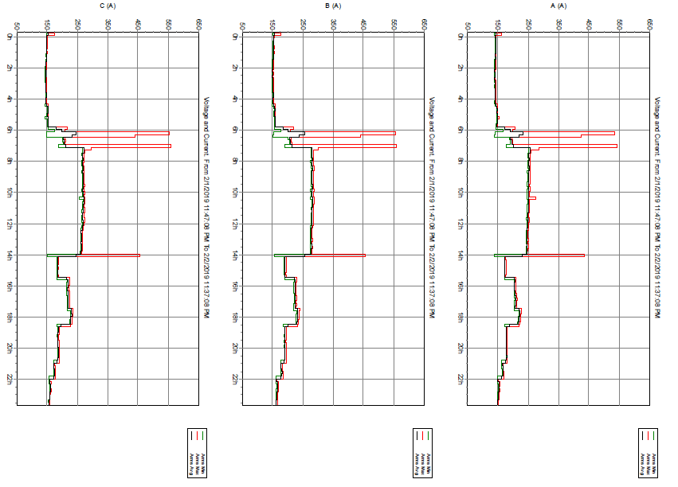

Figure 1.8 VFD-1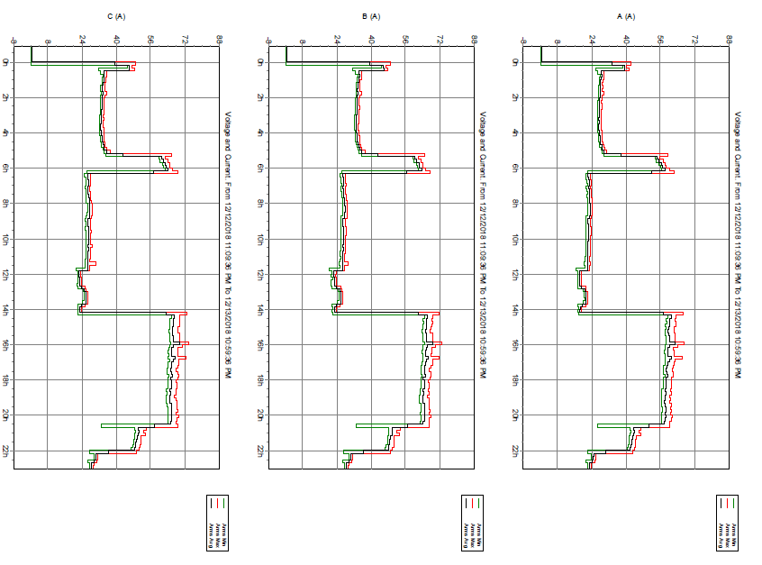

Figure 1.9 VFD2

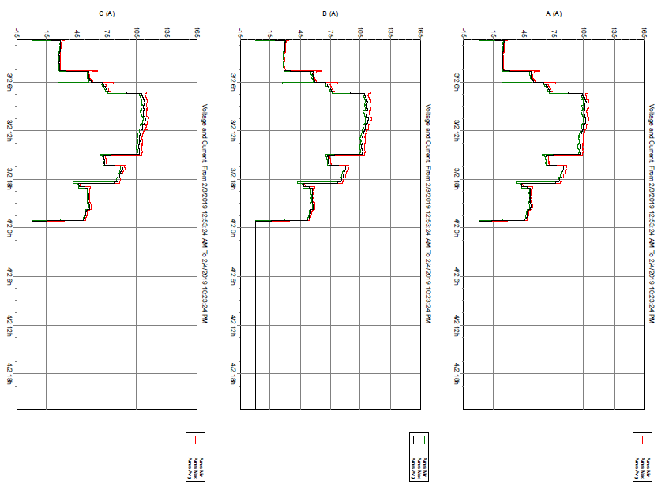

Figure 1.10 Softstarter